Curl and Div
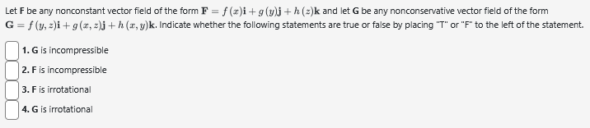

FTCLI

Calc vf line int
Library/Michigan/Chap18Sec2/Q33.pg (adapt this into an explanation of what happens for a piecewise defined path, possibly with stops)

10.1 Library/WHFreeman/Rogawski_Calculus_Early_Transcendentals_Second_Edition/13_Calculus_of_Vector-Valued_Functions/13.1_Vector-Valued_Functions/13.1.28.pg (adapt to a by hand explaination)
10.1 Library/maCalcDB/setParametric1Curves/ur_pa_1_6.pg (horiz or vert tangents, will need to trim problem)
10.2 Library/WHFreeman/Rogawski_Calculus_Early_Transcendentals_Second_Edition/13_Calculus_of_Vector-Valued_Functions/13.3_Arc_Length_and_Speed/13.3.14.pg (adapt for by hand ?)
10.2 Library/WHFreeman/Rogawski_Calculus_Early_Transcendentals_Second_Edition/13_Calculus_of_Vector-Valued_Functions/13.3_Arc_Length_and_Speed/13.3.29.pg (adapt for by hand)

9.3:
